**Unit 8 : Ideal gases & Real Gases**

**Introduction**

An ideal gas is a gas having no forces of intermolecular attraction. The gases which follow the gas laws at all range of pressures and temperatures are considered as ‘ideal gases’. An ideal gas obeys the perfect gas equation Pv = RT and has constant specific heat capacities.

A real gas is a gas having forces of inter molecular attraction. At very low pressure relative to the critical pressure or at very high temperatures relative to the critical temperature, real gases behave nearly the same way as a perfect gas. But since at high pressure or at low temperatures the deviation of real gases from the perfect gas relation is appreciable, these conditions must be observed carefully, otherwise errors are likely to result from inappropriate application of the perfect gas laws.

Due to these facts, numerous equations of state for real gas have been developed, the derivation of which is either analytical, based on the kinetic theory of gases, or empirical, derived from an experimental data.

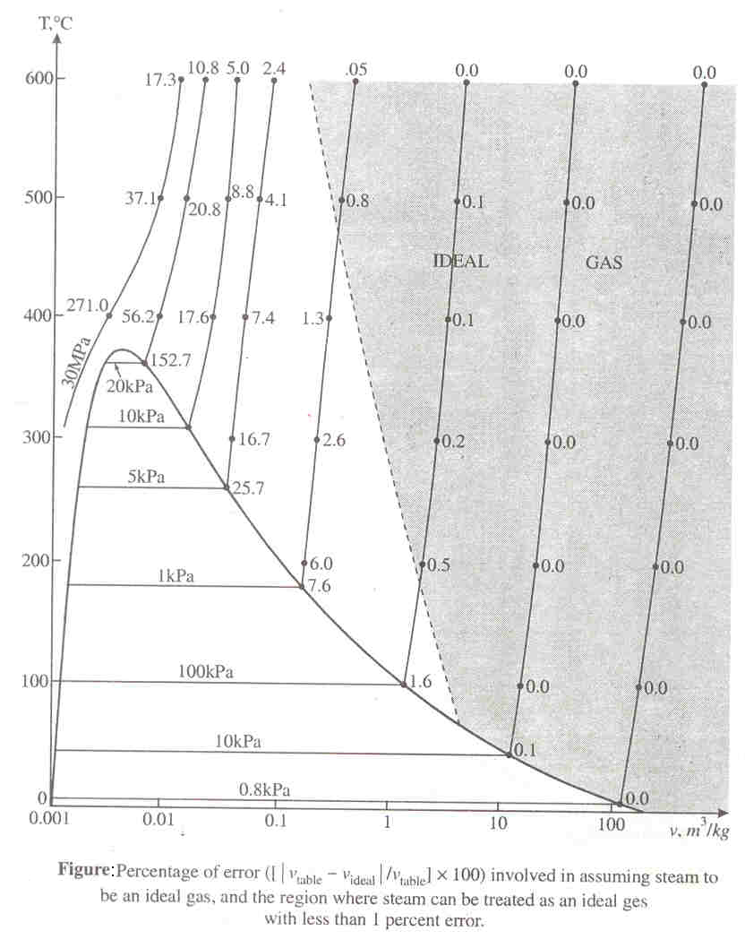

**Vander Waals’ Equation of State:**

In deriving the equation of state for perfect gases it is assumed that the volume occupied by the molecules of the gas in comparison to the volume occupied by the gas and the force of attraction between the adjacent molecules is very small and hence the molecules of gas are neglected. At low pressures, where the mean free path is large compared to the size of the molecules, these assumptions are quite reasonable. But at high pressure, where the molecules come close to each other, these are far from correct. Vander waals’ equation introduces terms to take into account of these two modifying factors into the equation of state for a perfect gas.

The Vander Waals’ equation of state is given by,

 --- (1)

 P = Pressure v = Volume/unit mass R = gas constant

where a and b are constants for any one gas, which can be determined experimentally, the constants account for the intermolecular attractions and finite size of the molecules which were assumed to be non-existent in an ideal gas. The term accounts for the intermolecular forces i.e, force of cohesion and the term b was introduced to account for the volume occupied by the molecules i.e., co-volume.

If the volume of one mole is considered, then the above equation can be written as,



Units P (N/m2), 







**Determination of Van der Waals constants in terms of critical properties**

The determination of two constants a and b in the Van der Waals equation is based on the fact that the critical isotherm on a p-v diagram has a horizontal inflexion point at the critical point. Therefore the first and second derivative of P with respect v at the critical point must be zero.



From equation (1) we have, 





At critical points the above equation reduces to

 --- (2a)

 --- (2b)

Also from equation (1) we have,  --- (2c)

Dividing equation (2a) by equation (2b) and simplifying we get



Substituting for b and solving for ‘a’ from equation (2b) we get

a = 9RTcvc

Substituting these expressions for a and b in equation (2c) and solving for vc, we get







If the volume of one mole is considered then the above equation can be written as



Units: P (N/m2), 

R =8314 Nm/kg mol0K 

a = Nm4 / (kg–mol)2 Or bar (m3/kg-mole)2 b = m3/kg-mol

Note: Usually constants a and b for different gases are given.

**Compressibility Factor and Compressibility Chart:**

The specific volume of a gas becomes very large when the pressure is low or temperature is high. Thus it is not possible to conveniently represent the behavior of real gases at low pressure and high temperature.

For a perfect gas, the equation of state is Pv = RT. But, for a real gas, a correction factor has to be introduced in the perfect gas to take into account the deviation of the real gas from the perfect gas equation. This factor is known as the compressibility factor, Z and is defined as,



Z = 1 for a perfect gas. For real gases the value of Z is finite and it may be less or more than unity depending on the temperature and pressure of the gas.

**Reduced Properties:**

The real gases follow closely the ideal gas equation only at low pressures and high temperatures. The pressures and temperatures depend on the critical pressure and critical temperature of the real gases. For example – 1000C is a low temperature for most of the gases, but not for air or nitrogen. Air or nitrogen can be treated as ideal gas at this temperature and atmospheric pressure with an error which is <1%. This is because nitrogen is well over its critical temperature of -1470C and away from the saturation region. At this temperature and pressure most of the substances would exist in solid phase. Hence, the pressure and temperature of a substance is high or low relative to its critical pressure or temperature.

Gases behave differently at a given pressure and temperature, but they behave very much the same at temperatures and pressures normalized with respect to their critical temperatures and pressures. The ratios of pressure, temperature and specific volume of a real gas to the corresponding critical values are called the reduced properties.



**Law of Corresponding states:**

This law is used in the approximate determination of the properties of real gases when their properties at the critical state are known. According to this law, there is a functional relationship for all substances, which may be expressed mathematically as vR = f (PR,TR). From this law it is clear that if any two gases have equal values of reduced pressure and reduced temperature, they will have the same value of reduced volume. This law is most accurate in the vicinity of the critical point.

**Generalized Compressibility Chart:**

The compressibility factor of any gas is a function of only two properties, usually temperature and pressure so that Z1 = f (TR, PR) except near the critical point. This is the basis for the generalized compressibility chart.

The generalized compressibility chart is plotted with Z versus PR for various values of TR. This is constructed by plotting the known data of one or more gases and can be used for any gas.

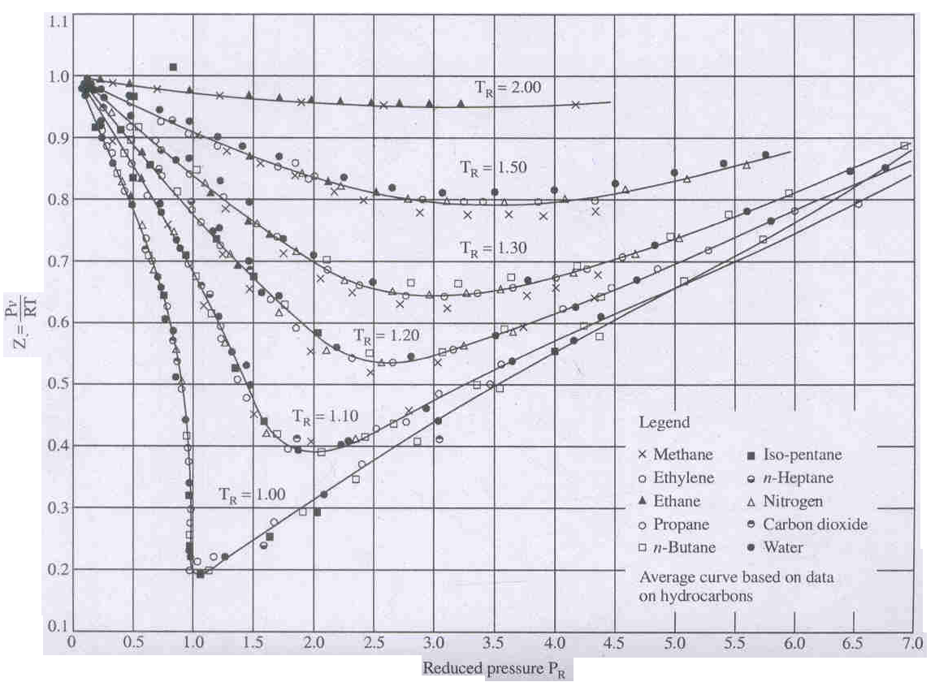

It may be seen from the chart that the value of the compressibility factor at the critical state is about 0.25. Note that the value of Z obtained from Van der waals’ equation of state at the critical point,  which is higher than the actual value.

The following observations can be made from the generalized compressibility chart:

* At very low pressures (PR <<1), the gases behave as an ideal gas regardless of temperature.
* At high temperature (TR > 2), ideal gas behaviour can be assumed with good accuracy regardless of pressure except when (PR >> 1).
* The deviation of a gas from ideal gas behaviour is greatest in the vicinity of the critical point.

The compressibility factor can also be obtained from v-T or v-P data. Since the critical volume may not be consistent with the generalized chart, the pseudo critical specific volume vc1 is used in the definition of reduced volume. It is defined by. The pseudo reduced volume

 is defined as 

Table: Critical Point Data of Gases

|  |  |  |  |  |
| --- | --- | --- | --- | --- |
| Gas | Chemical Formula | Pressure Pc bar | Temperature  Tc K | Specific Volume |
| Air | --- | 37.7 | 132.8 | 0.083 |
| Ammonia | NH3 | 112.8 | 405.8 | 0.073 |
| Argon | A | 44.7 | 151.0 | 0.075 |
| Carbon dioxide | CO2 | 73.8 | 304.2 | 0.094 |
| Carbon monoxide | CO | 35.0 | 133.0 | 0.093 |
| Freon-12 | CCl2F2 | 40.3 | 385.0 | 0.215 |
| Helium | He | 2.3 | 5.2 | 0.058 |
| Hydrogen | H2 | 13.0 | 33.2 | 0.065 |
| Nitrogen | N2 | 33.9 | 126.1 | 0.090 |
| Oxygen | O­2 | 50.6 | 154.5 | 0.075 |
| Sulphurdioxide | SO2 | 78.8 | 430.5 | 0.0123 |
| Steam | H2O | 220.9 | 647.3 | 0.056 |

Table: Van Der Waals’ Constant

|  |  |  |  |
| --- | --- | --- | --- |
| Gas | a  kN m4/(kg-mol)2 | b  m3/kg-mol | Z = pv/RT |
| Air | 135.8 | 0.0365 | 0.284 |
| Oxygen | 138.0 | 0.0318 | 0.29 |
| Nitrogen | 136.7 | 0.0386 | 0.291 |
| Water | 551.7 | 0.0304 | 0.23 |
| Methane | 228.6 | 0.0427 | 0.29 |
| Carbon monoxide | 147.9 | 0.0393 | 0.293 |
| Carbon Dioxide | 365.6 | 0.0428 | 0.276 |
| Ammonia | 424.9 | 0.0373 | 0.242 |
| Hydrogen | 24.8 | 0.0266 | 0.304 |
| Helium | 3.42 | 0.0235 | 0.30 |

**Problems**

1. A rigid vessel of volume 0.3 m3 contains 10 kg of air at 3000K. Using (a) the perfect gas equation, (b) the Vander Walls’ equation of state and (c) generalized compressibility chart, determine the pressure which would be exerted by the air on the vessel.

Solution: (a) The perfect gas equation is Pv = RT



Specific volume of the gas = 



(b) Vander Waals’ equation 

We have 

From the critical point data of gases, we have Tc = 132.8 K, Pc = 37.7 bar



a = 1.364 bar (m3/kg-mole)2

Also 

= 0.0366m3/kg-mole

Substituting the constants a and b in the Van der Waals’ equation of state, we get



Noting v = 0.03 m3/kg, 



We can also take the values of a and b from Thermodynamic Data Hand Book. [From table C-8 we have a = 135.8 kN m4/(kg-mol)2 and b = 0.0365 m3/kg-mol]

(c) The Pseudo reduced volume, 



The reduced temperature, 

At vR1 = 2.97 & TR = 2.26 from compressibility chart, PR = 0.75

Also since Pc = 37.7 bar,

The pressure exerted by the air on the cylinder P = PR x Pc = 0.75 (37.7) = 28.27 bar

Or

The pressure can also calculated by reading the value of compressibility factor from the chart.

At v1R = 2.97 and TR = 2.26 or TR = 2.26 and PR = 0.75, from the compressibility chart Z = 0.98



1. Determine the value of Zcp for the Vander Waals’ gas

Solution: From the isotherms plotted on P-v diagram it can be seen that the critical isotherm has an inflection point, whose tangent is horizontal at the critical point.



Where cp = critical point.

We have Vander Waals’ equation at the critical point,

 --- (1)

As Tcp is a constant,  --- (2)

 --- (3)





Substitute for b in equation (2), 



Substitute for a & b in equation (1)





As  

1. If the values for the reduced pressure and compressibility factor for ethylene are 5 bar and 1.04 respectively, compute the temperature.

Solution: From generated computer chart (from chart 7 in thermodynamic Data Hand Book compiled by B.T. Nijaguna and B.S. Samaga)

We find for PR = 5 & Z = 1.04, TR = 2.7

But 

∴T = (282.4) (2.7) Since for ethylene Tc = 282.40K

= 762.480K

1. Using the compressibility chart calculate (a) density of N2 at 260 bar & 150C. (b) What should be the temperature of 1.4 kg of CO2 gas in a container at a pressure of 200 bar to be have as an ideal gas.

Solution: For N2. from table C-6 (in thermodynamic Data Hand Book compiled by B.T. Nijaguna and B.S. Samaga) Tc = 125.90K Pc = 33.94



∴From chart 7, for PR = 7.66 & TR = 2.29, Z = 1.08



 Since R = 296.9 J/kg-0K from table C–6

= 281.54 kg/m3

(b) For CO2, from table C–6, Tc = 3040K, Pc = 73.85 bar.

As the gas behaves like an ideal gas, Z = 1



∴From compressibility chart (chart 7), for Z = 1 & PR = 2.71, TR = 2.46

∴T = Tc TR = 304 (2.46) = 747.840K

1. Find the pressure exerted by methane in a container of capacity 2m3, when it contains 3 kg at 3000K. Using (a) Ideal gas equation (b) Vander Waals’ equation.

Solution: Molecular weight of methane is McH4 = 16



Characteristic gas constant, 

(a) Using ideal gas equation

We have, Pv = mRT 

(b) We have 

From table C-8, a = 228.6 & b = 0.0427

Substituting in the above equation



1. Determine the mass of N2 contained in a 30 m3 vessel at 20 MPa and 200 K by using (a) the ideal gas equation (b) the generalized comp. chart.

(a) Ideal gas equation Pv = mRT



(b) From table C – 6 for N2, Pc = 33.94 bar Tc = - 147.10C = 125.90K





For PR = 0.589 & TR = 1.59 from chart Z = 0.9





1. The specific volume of CO2 at 1200C is 1.2 m3/kg. Determine the pressure exerted by CO2 using Van der Waals’ equation. If CO2 is treated as an ideal gas, what should be the pressure exerted.



Ans: P = 61.8 KPa Pid = 61.88 KPa

1. One kg mol of NH3 undergoes a reversible non-flow isothermal compression process and the volume decreases from 0.2 m3/kg to 0.1 m3/kg, the initial temperature being 450C. If the gas obeys Van-der-waals’ equation during the compression process, determine the work done during the process and final pressure.

Solution: MNH3= 17 

We have 





From tables, C – 8, a = 424.9 KN-m4/(kg-mol)2

b = 0.0373 m3/kg-mol

∴W1-2 = - 1737.098 KNm/kg-mole (kJ/kg-mol)

Final pressure 

1. Determine the pressure of CO gas having volume of 0.003m3/kg at 164 K with the use of generalized computer chart. Also determine if the volume of gas is reduced to 80% of the initial volume, what is the temperature of the gas at the same pressure?

Solution: From table C – 6, for CO, Tc = 134.3K, Pc = 34.96 bar

1. The Pseudo reduced volume, 

From chart 7, for 

∴Pressure, P = PRPc

= 2.6 (34.96)

= 90.81 bar

1. Volume is reduced to 80% of initial volume, ∴v = 0.8 (0.003) = 0.0024m3/kg



∴From chart 7, for vR1 & PR, Z ≅ 0.47, TR ≅1.15

∴Final temperature is T = TR - Tc

= 152.860K

1. Determine the compressibility factor for O2 at (i) 100 bar, - 700C and (ii) at 5 bar and 300C.

Ans: (i) 0.71 (ii) 0.98

1. Determine the pressure of air at 2050C having a specific volume of 0.00315 m3/kg using (i) Ideal gas equation and (ii) Van der Waals’ equation.

Ans: (i) 435.7 bar (ii) 557.3 bar

**Ideal Gas**

Definition: A substance is said to be an ideal gas if it satisfies the following equations

i.e., Pv = RT and u = f (T)

Where P is the pressure exerted by the substance, v is the specific volume of the substance, T is the temperature in degree Kelvin, u is the specific internal energy and R is the gas constant. Experience has shown that almost all real gases satisfy the above equations over wide ranges of pressures and temperatures. However there are certain situations where the real gases cannot be treated as ideal gases.

**Mole of a Gas**

A mole of a gas is that quantity of gas whose mass is numerically equal to its molecular weight. For example, 1 kg mol of hydrogen is equal to 2 kg, has molecular weight of hydrogen is 2. Therefore if n is the total number of moles, m is mass and M is the molecular weight then, nM=m

**Avogadro’s Hypothesis**

Avogadro’s law states that equal volumes of all gases measured at the same temperature and pressure contain the same number of moles.

Consider two gases A and B. The law states that if VA = VB, TA = TB and PA = PB then nA = nB

For gas A, the equation of state can be written as PA VA = mA RA TA = nA MA RA TA



Similarly for gas B we have 

According to Avogadro’s law, VA = VB, TA = TB and PA = PB then nA = nB. Therefore it follows that

MA RA = MB RB = 

Where  is called the universal gas constant and R is called the characteristic gas constant. The value of =8.3143 kJ/kgmole-K.

The ideal gas equation can also be written in terms of  as pV = nMRT = nT where = R/M

**Specific Heat of Ideal Gases**

From the definitionof specific heat at constant volume and the specific heat at constant pressure, we have



as u and h are functions of temperature.

From the above equations, du = cV dT and dh = cP dT

For a mass of m kg of gas the equations become

dU = m cV dT and dH = m cP dT

On integrating we get





**Relation between specific heats for an ideal gas**

For an ideal gas h = u + RT

Therefore 

Or cP= cV + R

ie, cP - cV = R

Dividing the above equation by cV, we get





Similarly, dividing the above equation by cP, we get



**Changes in internal energy, enthalpy and entropy for an ideal gas**

i**) Change in internal energy**

Let an ideal gas of fixed mass m undergoes a finite change of state from temperature T1 to temperature T2. Then the change in internal energy is given by





To integrate the above equation we should know the functional relationship between cV and dT. A perfect gas equation is one for which cv is a constant.

Therefore, U2-U1= m cv (T2 – T1)

**ii) Change in Enthalpy**





For a perfect gas cP is constant. Therefore the above equation can be integrated and we get

H2-H1= m cP (T2 – T1)

**Work done by a perfect gas during a reversible adiabatic process in a closed system:**

From the first law of TD,



For an adiabatic process, δq=0

Hence the work done by a unit mass of a perfect gas on a piston during an adiabatic expansion process is equal to the decrease in internal energy, i.e., δw = -du

Whereas, for an adiabatic compression process, the internal energy of the gas will increase with a consequent increase in temperature.

For a perfect gas, du=cvdT





Hence the work done during an adiabatic non-flow process between states 1 and 2 is given by









**Work done by a perfect gas during a reversible adiabatic Steady Flow process:**

Neglecting the effect of changes in velocity and elevation, SFEE for a unit mass of fluid is given by

Since the process is adiabatic, q=0. Hence work done per unit mass of a perfect gas during an adiabatic steady flow expansion process is equal to the decrease in enthalpy, i.e.,w1-2 = h1-h2

For a perfect gas, dh = cpdT

Therefore, w1-2 = cp(T1-T2)



the work done during an adiabatic steady flow process between states 1 and 2 is given by,









It may be noted that the work done for a steady flow system is γ times that for a closed system.

**Note**: The above equations may be derived for reversible processes by taking integral p dv for closed system and taking integral of minus v dp for a steady flow system with negligible changes in the kinetic and potential energies from the initial to the final state.

**The polytropic process of a perfect gas:** A Polytropic process is one for which the pressure volume relation is given by pvn = constant, where the exponent n for the given process is a constant and may have any numerical value ranging from plus infinity to minus infinity.

From the above equation, it is evident that the properties at the end states of the reversible or irreversible polytropic process of a perfect gas may be written in the form



There are four values of the exponent n that indicate processes of particular interest. When

* n = 0, constant pressure or isobaric process
* n = ± ∞, constant volume or isovolumic process
* n = 1, constant temperature or isothermal process and
* n = γ, constant entropy or isentropic process

These processes are shown in the fig. on p-v and T-s diagrams.

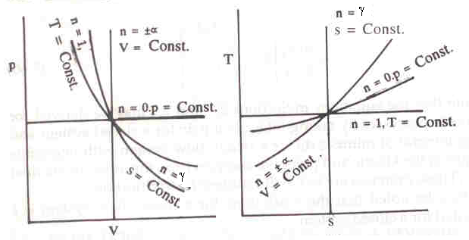

Figure: Polytropic Process on p-v and T-s diagrams

**Work done and heat transfer by a perfect gas during a polytropic process:**

For the closed system, the work done during a polytropic expansion process is given by,







The work done for a steady flow system during a polytropic expansion process is given by,







It may be noted that the work done for a steady flow system is n times that for a closed system.

**i) The heat transfer for a closed system**:

From the first law of thermodynamics for a unit mass of substance

δq = δw + du

Since du = cvdT and for a reversible process δw = pdv

δq = cvdT + pdv

Therefore heat transfer per unit mass during a polytropic process in a closed system from the initial state to final state is given by

















**ii) The heat transfer in a steady flow process**:

From the first law for steady flow system for a unit mass of fluid

δq = δw + dh

But dh = cpdT and for a reversible steady flow process δw = -vdp

Therefore δq = cpdT - vdp





Therefore heat transfer, 









**Change in Entropy**

Let P1, v1, T1, S1 apply to the initial conditions of certain amount of gas. P2, v2, T2, S2, apply to the final conditions after adding some heat.

From first law of TD, δq = δw + du

δq = P.dv + du

Also by definition, du = cv dT

Therefore δq = P.dv + cvdT

Divide by T, 





From perfect gas equation for unit mass of gas, Pv = RT, therefore P/T = R/v



Therefore integrating, 

i.e., the change in entropy is given by

 --- (1)

Equation (1) can also be express in terms of pressure and volume.

We have 



Substituting this in equation (1) we get,



But cP – cv = R, i.e., cv + R = cP

 --- (2)

Equation (1) can also be represented in terms of temperature and volume.

We have 



Substituting this in equation (1) we get

  --- (3)

**Evaluation of change in entropy in various quasi static processes**

1. **Constant Volume Process**

We have δQ = δW + dU

δW = 0 for a constant volume process.

Therefore heat added, δQ = dU = m cv dT

Divide by T



Integrating, 



1. **Constant Pressure Process**

δQ = δW + dU

= P.dv + dU

= m R dT + mcv dT

= m (R + cv) dT

= m (cP – cv + cv)dT

= mcP dT

Divide by T, 

Integrating, 



1. **Isothermal Process**

We have δQ = δW + dU

But dU = 0



Divide by T, 

Integrating we get, 

1. **Reversible Adiabatic Process**

δQ = 0

Therefore S2 – S1 = 0

Hence the process is called isentropic process

1. **Polytropic Process**

We know that for a perfect gas 

Divide by T, 



We know Pv = RT, i.e., P = RT/v







**Show that the entropy change for an ideal gas undergoing a polytropic process according to the equation Pvn = c is given by **

We have the change in entropy for unit mass of a substance between states (1) and (2) is given by



For a perfect gas, we know that 

Divide by T and integrating,





 









**Semi-perfect gas:**

It can be observed that from the definition of cp and cv that the specific heats can be either constants or functions of temperature.

A semi-perfect gas is one which follows the ideal gas relation with its specific heats being functions of temperature.

i.e., Pv = RT

And cp = Φ(T)

cv = f(T)

For example the constant pressure molal specific heat of air at low pressure is related to the temperature by the empirical relation



Where is in kJ/kg-mole K and T is in Kelvin.

It can be seen that integration of specific heat equation is time consuming. Hence Keenan and Kaye developed the gas tables (Table C-21) to take into account the variation of specific heats with temperature. Internal energy and enthalpy of various gases including air at low pressure for wide range of temperature are tabulated in these tables. The table illustrates the properties of air taking into account the variation of specific heats with temperature.

Gas table may also be used for isentropic processes of perfect gases to relate properties by introducing a relative pressure pr and a relative volume vr.

The entropy at a reference state where the temperature is T0 and the pressure is 1 bar is assumed as zero. Therefore at a temperature T and pressure p, the entropy s is given by



In gas tables an entropy function s0 is defined as



Since cp is a function of temperature, s0 is also a function of temperature for a perfect gas.

From the above equations we get s = s0 – R ln p

Therefore the change entropy of a perfect gas between states (1) and (2) can be written as



For an isentropic process, Δs = 0

Therefore 

A relative pressure pr is defined a ratio of the pressure p to the reference pressure p0.



Therefore from the above equation we can write,



Further from the equation state of perfect gas, we have



The relative volume vr is defined as



Using this equation in the above equation we get



The values of relative pressure pr and relative volume vr over a wide range of temperature are tabulated in gas tables.

**Problems**

1. 1.25 m3 of air at 1800C at 8 bar is undergoing a constant pressure until the volume is doubled. Determine the change in the entropy and enthalpy of air.

Solution: Assuming air behaves like a perfect gas we have, CP = 1.005 kJ/kg 0K,

Cv = 0.718 kJ/kg 0K and R = 0.287 kJ/kg 0K

Given: V1 = 1.25 m3, T1 = 180 + 273 = 4530 K, P1 = P2 = 8 x 105N/m2 and V2 = 2V1

For a constant pressure process, change in entropy is



We have P1V1 = mRT1







Therefore change in entropy = 

= 5.596 kJ/0K

Change in enthalpy = Q1-2 = mCP (T2 – T1) = 3500.99 kJ

1. 1kg of air initially at 270C is heated reversibly at constant pressure until the volume is doubled, and then is heated at constant volume until the pressure is doubled. For the total path find i) Work transfer, ii) Heat transfer, iii) Change in entropy

Solution: Given: m = 1 kg, T1 = 3000 K V2 = 2V1, P3 = 2P2 = 2P1

V

P

3

2

1

Process 1-2: Constant pressure process

i) Work done, W1-2 = P (V2 – V1)

= PV2 – PV1

= mR (T2 – T1)



But P1 = P2 

Therefore T2 = 2T1 = 6000K

Therefore work done W1-2 = 1 x 0.287 x (600 – 300)

= 86.1 kJ

ii) From first law of TD, Heat Transfer, Q1-2 = W1-2 + (U2 – U1)

= W1-2 + mCv (T2 – T1)

= 86.1 + 1 x 0.718 x (600 – 300)

= 301.5 kJ

iii) Change in entropy, 



= 0.6966 kJ/0K

Process 2-3: Constant Volume Process

Given, P3 = 2P2, T2 = 600 K





= 2 x T2 = 12000K

* 1. Work done, W2-3 = 0
  2. Heat transfer, Q2-3 = W2-3 + (U­3 – U2)

= mCv (T3 – T2)

= 430.8 kJ

* 1. Change in entropy 

= 0.4977 kJ/0K

Therefore work transfer in total path, W1-3 = W1-2 + W2-3

= 86.1 + 0

= 86.1 kJ

Heat transfer in total path, Q1-3 = Q1-2 + Q2-3

= 301.5 + 430.8

= 732.3 kJ

Change in entropy for the total path = (S3 – S1) = (S3 – S2) + (S2 – S1)

= 0.4977 + 0.6966

= 1.1943 kJ/0K

1. A mass of air is initially at 2600C and 700 kPa, and occupies 0.028m3. The air is expanded at constant pressure to 0.084m3. A polytropic process with n = 1.5 is then carried out, followed by a constant temperature process which completes a cycle. All the processes are reversible. (i) sketch the cycle in the P-v and T-s diagrams. (ii) find the heat received and heat rejected in the cycle. (iii) find the efficiency of the cycle.

Solution: P1 = 700 kPa, T1 = 533K = T3, V1 = 0.028m3, V2 = 0.084m3

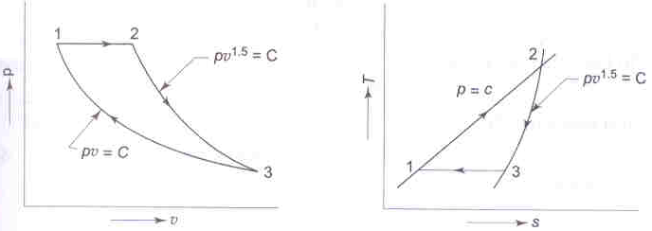

We have P1V1 = mRT1





Therefore T2 = 3 x 533 = 1559 K



Heat transfer in process 1-2, Q1-2 = mcp (T2 – T1)

= 0.128 x 1.005 (1599 – 533)

= 137.13kJ

Heat transfer in process 2 -3,







On substituting Q2-3 = - 19.59 kJ

For process 3-1

Q3-1 = dU + W3-1

But dU = 0, i.e., 

On substituting, Q3-1 = - 64.53 kJ

Heat received in the cycle 137.13 kJ

Heat rejected in the cycle Q2 = 19.59 + 64.53 = 84.12 kJ

The efficiency of the cycle



1. 1 kg of air at a pressure of 7 bar and a temperature of 900C undergoes a reversible polytropic process which may be represented by PV1.1 = C, final pressure is 1.4 bar. Evaluate i) The final specific volume, temperature and increase in entropy, ii) Work done and heat transfer.

Solution: Given, m = 1 kg, P1 = 7 bar, T1 = 3630K, PV1.1 = C, P2 = 1.4 bar

Air is perfect gas i.e., P1V1 = mRT1



Also we have, P1V11.1 = P2V21.1

Therefore V2 = 0.6429 m3

Also P2V2 = mRT2

Therefore T2 = 313.610K

Change in entropy for a polytropic process is,



Substituting the values, noting γ = 1.4 and R = 0.287 kJ/kg0K, we get

S2 – S1 = 0.31495kJ/kg0K

Work done, 

Substituting we get, W1-2 = 141.75 kJ/kg

Heat transfer Q1-2 = W1-2 + (U2 – U1)

= W1-2 + mCv (T2 – T1)

= 141.75 – 35.462

= 106.29 kJ/kg

1. Show that for a reversible adiabatic process the equation is Pvγ = Constant.

Solution: The general property relations for an ideal gas may be written as

Tds = du + pdv

= cvdT + pdv

And, also Tds = dh – vdp

= cpdT – vdp

For a reversible adiabatic change, ds = 0

Therefore cv dT = - pdv

And cp dT = vdp

By division,





Or d (ln p) + γd (ln v) = d (ln c) where c is the constant

Therefore ln p + γln v = ln c

i.e., pvγ = constant

1. The cooking gas cylinder (mostly methane) is about 250mm in diameter and 800mm in height. It is charged to 12 MPa at room temperature of 270C. i) Assuming ideal gas law, find the mass of the gas filled in the cylinder, ii) If the cylinder is to be protected against excessive pressure by means of a fusible plug, at what temperature the plug has to melt to limit the maximum pressure to 15 MPa? Assume the molecular weight of methane to be 16kg/kg-mole.

Solution: Volume of the cylinder=V= , M=16, T=3000K,

P=12x106 N/m2, 



When the pressure is limited to 15 MPa the corresponding temperature is



1. Show that for an ideal gas, the slope of the constant volume line on the T-s diagram is more than that of the constant pressure line.

Solution: We have for 1 kg of ideal gas,

Tds = du + pdv

= cv dT + pdv



Also Tds = dh – vdp

= cpdT – vdp





i.e., the slope of the constant volume line passing through a point is steeper than that of the constant pressure line passing through same point.

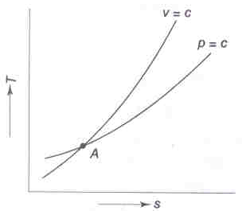

1. A mass of 0.25 kg of an ideal gas has a pressure of 300 kPa, a temperature of 800C, and a volume of 0.07 m3. The gas undergoes an irreversible adiabatic process to a final pressure of 300 kPa and final volume of 0.1 m3 during which the work done on the gas is 25 kJ. Evaluate the cp and cv of the gas and increase in entropy of the gas.

Solution: We have, P1 V1 = mRT1



Final temperature 

We have from first law of TD, Q – W = U2 – U1

But Q = 0 Therefore W = U1 – U2

W = mcv (T1 – T2)

On substituting, -25 = 0.25 x cv x (353 – 505)

Therefore cv = 0.658 kJ/kg-K

Now R = cp – cv

Therefore cp = 0.896 kJ/kg-K

Entropy change





= 0.08 kJ/kg-K

1. An ideal gas cycle consisting of three processes uses Argon (M = 40) as a working substance. Process 1-2 is a reversible adiabatic expansion from 0.014m3, 700 kPa, 2800C to 0.056m3. Process 2-3 is a reversible isothermal process and process 3-1 is a constant pressure process. Sketch the cycle on P-v and T-s diagrams and determine (i) work transfer in each of the three processes (ii) heat transfer in each of the three processes and (iii) net work output from the cycle. Assume for Argon γ = 1.67.

Solution: M = 40, V1 = 0.014m3, P1 = 700 kPa, T1 = 553 K

V2 = 0.056m3, γ = 1.67

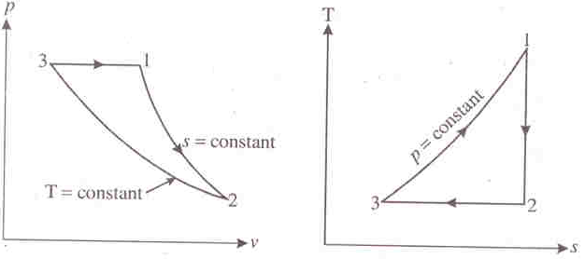

Figure P-v and T-s diagrams

Process 1-2 Reversible adiabatic process





cp = 0.208 + 0.311 = 0.519 kJ/kg-K

Since the process is reversible adiabatic, the working substance is treated as an ideal gas







= 8.85 x 103J = 8.85 kJ

Q1-2 = 0 as the process is reversible adiabatic.

Process 2-3 Reversible isothermal process

T2 = T3 = 218.45 K







= - 22.69 x 103J = - 22.69 kJ

By first law of TD Q2-3 = (U3 – U2) + W2-3

But U3 – U2 = mcv (T3 – T2) = 0

Therefore Q2-3 = W2-3 = - 22.69 kJ

Process 3-1 Constant Pressure Process

W3-1 = (P1V1 – P3V3) = mR (T1 – T3)

= 0.2157 x 0.208 x 103 (553 – 218.45) = 15 kJ

Therefore Net work output from the cycle = Wc = W1-2 + W2-3 + W3-1

= 8.85 – 22.69 + 5.93

= - 7.91 kJ

For the cyclic process we have



0 - 22.69 + Q3-1 = - 7.91

Therefore Q3-1 = 14.78 kJ

1. A mass of an ideal gas exists initially at 200 kPa, 300K and 0.5 m3/ kg. The value of γ is 1.4. (i)Determine the specific heats of the gas. (ii)What is the change in entropy when the gas is expanded to a pressure of 100 kPa according to the law pv1.3 = constant (iii) What will be the change in entropy if the process is according to the law pv1.5 = constant (iv) What inference you can draw from this example.

Solution: P1 = 200 kPa, T1 = 300 K, v1 = 0.5 m3/kg, γ =1.4, P2 = 100 kPa

1. For an ideal gas P1v1 = RT1 or 



1. For the given process 





Change in entropy per unit mass is given by



= 44.18J/K

1. For the process for which the index n = 1.5 we have







= - 38.07 J/K

1. It can be seen from the results of (ii) and (iii) above that entropy increases when n < γ and it decreases when n > γ.
2. A closed rigid cylinder is divided by a diaphragm into two equal compartments, each of volume 0.1 m3. Each compartment contains air at a temperature of 200C. The pressure in one compartment is 2.5 MPa and in the other compartment it is 1 MPa. The diaphragm is ruptured so that the air in the compartments mix to bring the pressure to a uniform value through the insulated cylinder. Find the net change in entropy due to mixing process.

Solution: Let suffix 1 denote the condition of air in the left half of the cylinder, suffix 2 the conditions in the right half of the cylinder and suffix 3 the condition after mixing

It if given that,

V1 = V2 = 0.1 m3, T1 = T2 = 20 + 273 = 293K, P1 = 2.5 MPA, P2 = 1.0 MPa

After mixing the temperature is given by



Since T1 = T2 and cp1 = cp2, it follows that T3 = T1 = T2 = 293 K

(ΔS)universe = (ΔS)1 + (ΔS)2 + (ΔS)surroundings

(ΔS)surroundings = 0 as the cylinder is insulated and no heat transfer can take place during the mixing process.

Therefore (ΔS)universe = (ΔS)1 + (ΔS)2







Therefore on substituting, (ΔS)universe = 0.828kJ/K

1. 1 kg of air expands isentropically in a steady flow process from an initial state of 6.5 bar and 500 K to a final state of 1 bar. Neglecting kinetic and potential energies, assuming the air to be a semi perfect gas, compute the temperature of the air at the final state and work developed during the process.

Solution: From table C-21 (Thermodynamic Data Hand Book, by B.T. Nijaguna and B.S. Samaga) at T1 = 500 K Pr1 = 8.411 and h1 = 503.02 kJ/kg





Again from table C-21 at Pr2 = 1.294, by interpolation, h2 = 294.2 kJ/kg and T2 = 294 K

From SFEE, work developed w = h1 – h2 = 503.02 – 294.2 = 208.82 kJ/kg

1. Air is compressed from 1 bar, 270C to 4.5 bar, 1770C. Determine the change in entropy per kg of air (i) taking variation of specific heats into account and (ii) assuming specific heat at constant pressure to be constant and is equal to 1.01 kJ/kg-K over this range of temperature.

Solution: T1 = 300 K, T2 = 450 K, P1 = 1 bar, P2 = 4.5 bar

(i) We have change in entropy per kg of air, 

From table C-21 at T1 = 300 K, and

at T2 = 450 K, 

Therefore on substituting, s2 – s1 = - 0.02508 kJ/kg-K

(ii) The change in entropy per kg of air





**Thermodynamics of Non-reactive Mixtures**

**Assumptions:**

1. Each individual constituent of the mixture behaves like a perfect gas.
2. The mixture behaves like a perfect gas.
3. Individual constituents do not react chemically when the mixture is undergoing a process.

**Mixture characteristics:**

P,

T,

V

a,

b,

c,

.

.

.

Figure: Homogeneous gas mixture

Consider a mixture of gases a, b, c, …. existing in equilibrium at a pressure P, temperature T and having a volume V as shown in figure.

The total mass of the mixture is equal to the sum of the masses of the individual gases,

i.e., mm = ma + mb­ + mc + …….. where subscript m = mixture, a, b, c = individual gases.

**Mass fraction:** The mass fraction of any component is defined as the ratio of the mass of that component to the total mass of the mixture. It is denoted by mf.





Where the subscript i stands for the ith component. It shows that the sum of the mass fraction of all components in a mixture is unity.

**Mole fraction:** If the analysis of a gas mixture is made on the basis of the number of moles of each component present, it is termed a molar analysis. The total number of moles for the mixture is equal to the sum of the number of moles of the individual gases

i.e., nm = na + nb + nc + …….. where subscript m = mixture, a, b, c = individual gases.

(A mole of a substance has a mass numerically equal to the molecular weight of the substance, i.e., 1 kg mol of O2 has a mass of 32 kg, 1 kg mol of N2 has a mass of 28 kg, etc.,)

The mole fraction of any component is defined as the ratio of the number of moles of that component to the total number of moles. It is denoted by y





i.e., the sum of the mole fraction of all components in a mixture is unity.

The mass of a substance m is equal to the product of the number of moles n and the molecular weight (molar mass) M, or m = nM

∴For each of the components we can write,

nm Mm = na Ma + nb Mb + ncMc + ......

Where Mm is the average molar mass or molecular weight of the mixture.

Or Mm = yaMa + ybMb + ycMc

Thus, the average molecular weight of a gas mixture is the sum of the products of all the components of the mole fraction and corresponding molecular weight of each component.

Note: Universal gas constant  where M = molecular weight, R: specific gas constant, and =8.3143 kJ/kg-mole K

**Partial Pressure:**

a & b = gases of the mixture

V = Total volume of the mixture

T = Temperature of the mixture

P = Pressure of the mixture

P,

T,

V

a+b

Mixture

Partial pressure of a constituent in a mixture is the pressure exerted when it alone occupies the mixture volume at mixture temperature. If Pa is partial pressure of gas ‘a’, then PaV = maRaT

Where ma = mass of gas ‘a’, Ra = gas constant for gas ‘a’, similarly PbV = mbRbT

**Partial Volume:** Partial volume of a gas in a mixture is the volume occupied by the gas component at mixture pressure and temperature. Let Va = partial volume of gas ‘a’ and Vb = partial volume of gas ‘b’

i.e., PVa = maRaT & PVb = mbRbT

**The Gibbs-Dalton Law**

Consider a mixture of gases, each component at the temperature of the mixture occupying the entire volume occupied by the mixture, and exerting only a fraction of the total pressure as shown in figure.

mm, pm,

T, V

mc, pc,

T, V

mb, pb,

T, V

ma, pa,

T, V

+ + + ................. =

Applying the equation of state for this mixture we may write,

Pm V = mm Rm T = nm Mm Rm T = nm T







We know that nm = na + nb + nc + ......



Or pm = pa + pb + pc + ....... ⏐V,T = Σpi

The above equation is known as the Gibbs Dalton Law of partial pressure, which states that the total pressure exerted by a mixture of gases is equal to the sum of the partial pressures of the individual components, if each component is considered to exist alone at the temperature and volume of the mixture.

**Gas constant for the mixture:**

We have PaV = maRaT

PbV = mbRbT

Or (Pa + Pb) V = (maRa + mbRb) T

Also, since the mixture behaves like a perfect gas,

We have PV = mRT --- (1)

By Dalton’s law of partial pressure, which states that, the pressure of mixture of gas is equal to the sum of the partial pressures of the individual components, if each component is considered to exist alone at the temperature and volume of the mixture.

i.e., P = Pa + Pb

∴PV = (maRa + mbRb) T --- (2)

From equation (1) and (2), mR = maRa + mbRb



Also for gas mixture, PaV = maRaT

= naMaRaT



Similarly 



Similarly it can be shown that mole fraction = volume fraction



**Molecular weight of the mixture:**

We have, PaV = maRaT

PaV = naMaRaT Similarly PbV = nb­MbRbT

∴(Pa + Pb) V = (n­aMaRa + nbMbRb) T

Also PV = nMRT

By Dalton’s law of partial pressure, P = Pa + Pb

∴nMRT = (naMaRa + nbMbRb) T

MR = yaMaRa + ybMbRb



Also, mR = maRa + mbRb

R = mfaRa + mfbRb









**The Amagat-Leduc Law:** Expresses the law of additive volume which states that the volume of a mixture of gases is equal to the sum of the volumes of the individual components at the pressure and temperature of the mixture.

i.e., Vm = Va + Vb + Vc ….⏐P, T = 

For Dalton law, Pm = Pa + Pb +Pc + ….⏐V, T = 

**Gibb’s Law:** It states that the internal energy, the enthalpy and the entropy of a mixture of gas is equal to sum of the internal energies, the enthalpies and entropies respectively of the individual gases evaluated at mixture temperature and pressure.

∴U = Ua + Ub

mU = maUa + mbUb

U = mfaUa + mfbUb



Similarly CP = mfa (Cp)a + mfb (Cp)b

If  Specific heat at constant volume on mole basis

 Specific heat at constant pressure on mole basis





**Isentropic process of gaseous mixture:** When a mixture of say two gases, a & b, is compressed or expanded isentropically, the entropy of the mixture remains constant i.e., there is no change in the entropy of the entire system. i.e., ΔSm = ΔSa + ΔSb = 0

But this does not mean that there is no change in the entropy of an individual gas. During the reversible adiabatic compression or expansion process, the entropy of one of the two gases will increase, while the entropy of the other one will decrease by the same amount, and thus, as a whole, the entropy of the system will remain constant.

The compression or expansion of each constituent will be reversible, but not adiabatic and hence the energy transferred as heat from one of the two gases must be exactly equal to the energy received by the other one. This is also true when more than two gases are involved in the process.

**Volumetric and Gravimetric Analysis:** When the analysis of a gaseous mixture is based on the measurement of volume, it is called a volumetric analysis, whereas when it is based on the measurement of mass, it is called the gravimetric analysis. Flue gases generally contain CO2, CO, N2 O2 and H2O in the form of vapour.

The volumetric analysis of a dry flue gas is generally done with Orsat apparatus, which is designed to absorb CO2, O2 and CO. The N2 content of the gas is obtained by difference.

**Note 1**: The volume fraction & mole fraction of each individual gas are equal. This enables the conversion of the volumetric analysis to gravimetric analysis and vice versa.

**Note 2**: Molecular weight of common gases is given in Table C-6.

**Note 3**: Specific heat of gases at constant pressure CP are given in Table C-11

**Problems:**

1. A perfect gas mixture consists of 2.5 kg of N2 and 1.5 kg of CO at a pressure of 2 bar and at a temperature of 150C. Determine (a) The mass and mole fraction of each constituent, (b) The equivalent molecular weight of the mixture, (c) The partial pressure of each gas, and (d) The specific gas constant of the mixture.

Solution: (a) The total mass of the mixture mm = 2.5 + 1.5 = 4 kg

∴The mass fraction 



The mass of the substance m = nM





∴Total no. of moles in the mixture, nm = 0.0893 + 0.0536 = 0.1429

∴ The mole fraction of each constituent,





(b) The equal molecular weight of the mixture, 

= 0.625 (28) + 0.375 (28)

= 28 kg/kg-mole

(c) The partial pressure of 

The partial pressure of 

(d) The specific gas constant of the mixture, 



= 0.625 (0.297) + 0.375 (0.297)

= 0.297 kJ/kg-0K

1. A mixture of gas has the following volumetric analysis. O2 = 30%, CO2 = 40%, N2 = 30%. Determine (a) the analysis on a mass basis (b) the partial pressure of each component if the total pressure is 100 kPa and a temperature is 320C (c) the molecular weight of the mixture.

Solution: VO2 / Vm = VfO2 = 0.3, VCO2 / Vm = VfCO2 = 0.4, VN2 / Vm = VfN2 = 0.3, P = 100 x 103Pa T = 305 K

We know that, Vfi = yi = Pi /Pm

Therefore, yO2 = 0.3, yCO2 = 0.4, yN2 = 0.3,

∴PO2 = 0.3 (1) = 0.3 bar;

PCO2 = 0.4 bar & PN2 = 0.3 bar

Also PO2V = mO2RO2T

& PmV = mmRmT



 --- (1)

Mm = yO2MO2 + yCO2MCO2 + yN2MN2

= 0.3 (32) + 0.4 (44) + 0.3 (28)

= 35.6 kg/kg-mole



Therefore from equation (1),







1. A mixture of perfect gas at 200C, has the following composition by volume, N2 55%, O2 20%, methane 25%. If the partial pressure of methane is 0.5 bar, determine (i) partial pressure of N2 & O2, (ii) mass fraction of individual gases, (iii) gas constant for the mixture (iv) molecular weight of the mixture.

Solution: Let Vm = Total volume of the mixture



(i) We have 







Molecular weight of the mixture, Mm = yN2 MN2 + yO2 MO2 + yCH4 MCH4

= 0.55 (28) + 0.2 (32) + 0.25 (16)

= 25.8 kg/kg-mole

Gas, constant of the mixture, 

Mass Fraction

We have PN2 V = mN2 RN2 T

& PmV = mmRmT











1. A mixture of 3.5 kg of O2 & 2.5 kg N2 is stored in a vessel of 0.3 m3 at a temperature of 270C. Find the partial pressures and mole fraction of each constituent. Also determine the molecular weight and characteristic gas constant for the mixture.

Solution: mO2 = 3.5 kg mN2 = 2.5 kg Vm = 0.3 m3 T = 3000K. PO2 = ?

PN2 = ? yO2 = ? yN2 = ? Mm = ? Rm = ?

We have m = nM



∴nm = 0.1094 + 0.0893 = 0.1987 moles



The average molecular weight, Mm = yO2 MO2 + yN2 MN2

= 0.5506 (32) + 0.4494 (28)

= 30.204

The characteristic gas constant, 

Partial Pressure:

We have PmVm = mmRmT







Or PN2 = Pm – PO2 = 16.52 – 9.095 = 7.424 bar

1. A mixture of ideal gases consists of 3 kg of N2 and 5 kg of CO2 at a pressure of 300 kPa and a temperature of 200C, determine (i) the mole fraction of each constituent (ii) molecular weight of the mixture (iii) gas constant of the mixture (iv) the partial pressure and partial volumes of the constituent.

Solution: mN2 = 3 kg mCO2 = 5 kg Pm = 300 x 103N/m2 Tm = 2930K

(i) We have m = nM



∴Total no. of moles in the mixture = nm = 0.1071 + 0.1136 = 0.2207 moles



(ii) Mm = yN2 MN2 + yCO2 MCO2

= 0.4852 (28) + 0.5146 (44)

= 36.23 kg/kg-mole

(iii) 

(iv) PN2 = yN2 Pm = 0.4852 (3) = 1.456 bar

PCO2 = yCO2 Pm = 0.5146 (3) = 1.544 bar

Also Pm VN2 = mN2 RN2 T





Similarly Pm VCO2 = mCO2 R­CO2 T





1. A gaseous mixture contains 21% by volume N2, 50% by volume of H2 and 29% by volume of CO2. Calculate (i) the molecular weight of the mixture (ii) gas constant of the mixture (iii) the ratio of specific heats of the mixture. Assume that CP for N2, H2 and CO2 as 1.038, 14.235 and 0.821 kJ/kg-0K respectively.

Solution: We have ya = vfa = PaPm

Given: yN2 = 0.21 yH2 = 0.5 yCO2 = 0.29

Mm = yN2MN2 + yH2MH2 + yCO2MCO2

= 0.21 (28) + 0.5 (2) + 0.29 (44) = 19.64 kg/kg-mole

Gas constant 

(iii) We have PN2V = mN2RN2T

& PmV = mmRmT













Specific heat at constant pressure for the mixture,



= 0.2994 (1.038) + 0.1018 (14.235) + 0.6496 (0.821)

= 2.2932 kJ/kg-0K



= 2.2932 – 0.4233 = 1.8699 kJ/kg-0K

∴The ratio of specific heats of the mixture 

**Entropy of a Gas Mixture:**

Entropy of a gas mixture Sm = Sa + Sb + Sc + …….

The specific entropy on the mass basis

Sm = mfa sa + mfb sb + mfc sc + ….. = 

On differentiating we get

(dS)m = mfa (ds)a + mfb (ds)b + mfc (ds)c + ……

Expressing the entropy of a perfect gas as a function of temperature and pressure, the change in entropy is given by



On substituting this expression in the above equation, the change in entropy of a gas mixture in the differential form becomes



Assuming the specific heats as constant and integrating the above equation between states (1) and (2), the change in entropy of the perfect gas mixture on the mass basis can be written as



Similarly the change in entropy in the gas mixture on molal basis



where pa, 1, pb, 1 pc, 1 etc are partial pressures at state one and pa, 2, pb, 2 pc, 2 etc are partial pressures at state 2 of the constituent gases, a, b, c, etc respectively.

**Isentropic process of gaseous mixture**:

When the mixture of gases is compressed or expanded from state (1) to state (2) isentropically, we have 

Where γm is the specific heat ratio of the gaseous mixture, which is given by





On molal basis



**Adiabatic Mixing of Perfect Gases Initially at Same Temperature and Pressure**

Consider several gases of mass ma, mb, mc etc at the same temperature T and pressure p confined in separate compartment of an adiabatic vessel. When the partitions between compartments are pulled out from the vessel, the gases mix with each other until a new equilibrium state is attained.

Since in an adiabatic mixing processes, there is no heat transfer and also no work crosses the boundary of the system, for a closed system ΔU = 0 i.e., Uinitial = Ufinal. Hence the resulting temperature of the mixture remains the same as that of each gas before mixing. In other words, the mixing process is isothermal. However each gas after free expansion will attain the partial pressure of the mixture and each gas will occupy the entire volume of the vessel. By using the perfect gas equation, it can be shown that the total pressure of the mixture is equal to the initial pressure p of each individual gas.

As the mixing process is irreversible, according to the second law of thermodynamics, the entropy of the mixture increases. Assuming constant specific heats, the change in entropy of the gas a is given by



Since the temperature remains constant, T1 = T2

The change in entropy of the gas a may then be written as



Where the subscripts (1) and (2) refer to the initial and final states of the component a in the mixture.

Since the partial pressure pa,2 is less than the partial pressure pa,1 of the mixture which is equal to p, the pressure of the individual gas, the change in entropy is always positive. This conclusion is consistent with the fact that for an irreversible process, entropy always increases.

Similarly the change in entropy of the gas b



Hence the total change in entropy of the mixture is







Similarly on molal basis, the total change in entropy of the mixture



It is evident from the above equation that the increase in entropy of the mixture of perfect gases depends only on the number of moles of the component gases and is independent of the nature of the individual gases.

**Adiabatic Mixing of Perfect Gases Initial at Different Pressure and Temperature**:

Consider several gases of mass ma, mb, mc, etc, initially at different pressure and temperature confined at separate compartments in a thermally insulated vessel (adiabatic vessel). When the partitions are removed, the gases mix with one another. The mass and volume of the mixture are given by

mm = ma + mb + mc + …..

Vm = Va + Vb + Vc + …..

Where, ma, mb, mc, …. are the initial masses and Va, Vb, Vc …. are the initial volumes of each constituent respectively.

Since during the mixing process there is no heat and work interaction, the change in internal energy of the system is zero, i.e., the sum of the internal energies of the individual gases before mixing is equal to the internal energy of the mixture.

Or Um = Ua + Ub + …….

Taking 00C as the reference point, we get

mm (cv)m Tm = ma (cv)a Ta + mb (cv)b Tb + …



Where Tm is the temperature of the mixture. Similarly on molal basis,



Using equation of state, the final pressure of the mixture on mass basis is



Where Rm is the specific gas constant of the mixture. On molal basis the pressure of the mixture is, 

Since it is a irreversible adiabatic mixing process, the entropy must increase. Since the change in entropy of the mixture is equal to the sum of the changes in entropies of the individual gases, we can write



The change in entropy of individual gases can be calculated by considering that each individual gas exists alone and is expanded from the initial state to the temperature and volume of the mixture, the pressure at the final state being the partial pressure of the constituent in the mixture. Thus the changes in entropy of the constituent ‘a’ is



Where pa,1 is the initial pressure of the gas a and pa,2 is the partial pressure of gas a in the mixture. Similarly for gas b the change in entropy is



On molal basis,





**Problems**

1. The mass analysis of a gas mixture shows that it consists of 60% of N2 & 30% of CO­2 & 10% of CO. If the temperature and pressure of the mixture is 200C & 3 bar, compute (i) the partial pressure of the components, (ii) Molecular weight of the mixture, (iii) gas constant for the mixture.

Solution: We have 









Considering 1 kg of mixture, 

We have 













1. b) For a reference state of 00C and 1 bar also determine (i) constant pressure specific heat of the mixture (ii) enthalpy and internal energy of mixture (iii) entropy of mixture.

Solution: Constant pressure molal specific heat of a perfect gas is given by

 Where f = degree of freedom of the molecule.

At low temperatures, for monatomic gas f = 3, for diatomic gas, f = 5 and for polyatomic gas f = 6















= 0.6 (1.0393) + 0.3 (0.6614) + 0.1 (1.0393)

= 0.9259 kJ/kg-0K





(ii) Assuming that at 00C u = 0



= 13.229 kJ/kg

Enthalpy, h20 = 

= 13.229 + RT

= 13.229 + 0.2645 (293)

= 90.73 kJ/kg

(iii) Entropy at 00C and 1 bar is assumed to be zero







1. A tank of 0.7 m3 capacity contains O2 at a pressure of 5 bar and 320 K temperature. N2 is introduced without change in temperature until the pressure in the tank becomes 8 bar. Determine the mass of each gas in the tank and partial volume of each gas.

Solution: Vm 0.7 m3 PO2 = 5 bar T = 320 K Pm = 8 bar mO2 = ? mN2 = ?

VO2 = ? VN2 = ?

We have PO2V = mO2RO2T

PN2V = mN2RN2T

Also, Pm = PO2 + PN2 ∴PN2 = 3 bar

& PmV = mmRmT





Also PO2VO2 = mO2RO2T & 





1. a) A gaseous mixture contains 21% by volume of N2, 50% by volume of H2 and 29% by volume of CO2. Calculate the gas constant of the mixture and the ratio of specific heats. If the mixture pressure is at 1 bar and the mixture temperature is 100C, calculate the partial pressures and mass fractions of the constituents.

b) A cylinder contains 0.085m3 of this mixture at 1 bar and 100C. The gas undergoes a polytropic process according to the law Pv1.2 = constant to a final volume which is one fifth of the initial volume. Determine i) the magnitude and direction of work transfer, ii) magnitude and direction of heat transfer and iii) the change in entropy.

Solution: From tables C-6, MN2 = 28.02, MH2 = 2.016 and MCO2 = 44

From table C-11, CPN2 = 1.039 kJ/kg-K, CPH2 = 14.15 kJ/kg-K and CPCO2 = 0.818 kJ/kg-K

1. Given VN2 / V = VfN2 = 0.21, VH2 / V = VfH2 = 0.5, VCO2 / V = VfCO2 = 0.29

P = 1 bar, T = 283 K



Therefore CvN2 = 1.039 – 0.297 = 0.742 kJ/kg-K

CvH2 = 14.15 – 4.124 = 10.026 kJ/kg-K

CvCO2 = 0.818 – 0.189 = 0.629 kJ/kg-K

We know that volume fraction = mole fraction

i.e., yN2 = VfN2 = 0.21

yH2 = VfH2 = 0.5

yCO2 = VfCO2 = 0.29

Molecular weight of the mixture Mm = yN2 MN2 + yH2 MH2 + yCO2 MCO2

= 0.21 x 28.013 + 0.5 x 2.016 + 0.29 x 44

= 19.654 kg/kg-mole

Gas constant for the mixture = Rm = 8.3143 / 19.654

= 0.423 kJ/kg-K

Mass fraction of N2 



Similarly 



For the mixture Cvm = MfN2 CvN2 + MfH2 CvH2 + MfCO2 CvCO2

= 0.2993 x 0.742 + 0.0513 x 10.026 + 0.6494 x 0.629

= 1.145 kJ/kg-K

CPm = Cv + Rm

= 1.145 + 0.423

= 1.568 kJ/kg-K

Therefore the ratio of specific heat for the mixture is γm = CPm / Cvm

= 1.568 / 1.145

= 1.369

1. Mass of the mixture 

For the given process, 







Negative sign indicates that work is done by the surroundings on the gas mixture.

Temperature of the mixture at the end of the process is,



Or 

Change in internal energy, U2 – U1 = mCv (T2 – T1)

= 0.071 x 1.145 x (390.6 – 283)

= 8.747 kJ

By first law of TD, Q1-2 = W1-2 + (U2 – U1)

= - 16.15 + 8.747

= - 7.403 kJ

Negative sign indicates that heat transfer takes place from the mixture to the surroundings

Change in entropy of the mixture 



1. Calculate the constant volume and constant pressure specific heats of a gas mixture consisting of 1 kg of oxygen and 2 kg of nitrogen at a pressure of 1.5 bar and temperature 200C. Also determine the change in internal energy, enthalpy and entropy of the mixture when it is heated under constant volume to a temperature of 1000C.

Solution: From tables C-6, MO2 = 32, MN2 = 28

From table C-11, CPN2 = 1.038 kJ/kg-K, CPO2 = 0.917 kJ/kg-K

∴CvN2 = CpN2 – RN2 = 1.038 – 8.3143 / 28 = 0.741 kJ/kg-K

CvO2 = CpO2 – RO2 = 0.917 – 8.3143 / 32 = 0.653 kJ/kg-K









Change in internal energy,



= 3 x 0.712 (100 – 20)

= 170.88 kJ

Change in enthalpy,



= 3 x 0.998 (100 – 20)

= 239.52 kJ

Change in entropy of the mixture,



Since the volume is constant, the change in entropy,





= 0.5156 kJ/K

1. A gaseous mixture consisting of 1 kg of helium and 2.5 kg of nitrogen is compressed isentropically in a closed system from a pressure of 1 bar, 270C to a pressure of 7 bar. Assuming specific heats of helium and nitrogen to be constant, determine the specific heats of the mixture, the change in entropy of individual gases, and the change in internal energy of the mixture. Also find the work required for the compression process. Assume CvHe = 3.14 kJ/kg-K, CvN2 = 0.741 kJ/kg-K, CpHe = 5.233 kJ/kg-K and CpN2 = 1.038 kJ/kg-K

Solution: 













Hence the change in entropy of helium







= - 0.38 kJ/K

Similarly 

= + 0.38 kJ/K

Internal energy of the mixture



= 3.5 x 1.426 (607 – 300)

= 1532.24 kJ

For a closed system we have, δq – δw = du.

Since the process adiabatic, δq = 0

Therefore δw = -dU.

Therefore the work required for the compression process,

W1-2 = - (dU)m = - 1532.24 kJ

1. Two thermally insulated vessels, each of 0.85 m3 in volume are isolated from each other by a partition wall. One of the vessels contains nitrogen and the other oxygen, each at 5 bar and 1000C. As soon as the partition between the vessels is removed, the two gases mix adiabatically. Determine the increase in entropy of the gas mixture.

Solution: Since the pressure and temperature of each gas are equal, the pressure and temperature of the mixture will not change, i.e., the mixture will be at 5 bar and 373 K. But the volume of the mixture will be 2x0.85= 1.7m3 and the pressure of N2 and O2 is



Therefore pN2=0.5x5=2.5 bar and pO2=2.5 bar

Using perfect gas equation, mass of the N2,



and 

Therefore the increase in entropy of the mixture is,



 = 1.579kJ/K

1. Two kg-mole of CO2 at a pressure of 1.8 bar, 800C is mixed in a thermally insulated vessel with 3 kg-mole of N2 at 2.2 bar, 600C. When the mixture is at equilibrium, determine the final temperature and pressure and the change in entropy of the mixture. Assume CvCO2 = 0.653 kJ/kg-K, CvN2 = 0.741 kJ/kg-K

Solution: we have,

Now the molal specific heats at constant volume of the constituent gases are



= 44x0.653

=28.73 kJ/kg-mole K



=28x0.741

=20.75 kJ/kg-mole K



=342.6 K

The final pressure of the mixture is



The volume of the individual gases is,







Therefore the final pressure of the gas mixture is,



The partial pressure of the individual gases,





Therefore the entropy change of the mixture,









=37.04 kJ/kg mole K



=29.064 kJ/kg mole K





=2[-1.108+6.659]+3[0.826+4.957]

=28.45 kJ/ K

